What are spider veins?
Spider veins are similar to varicose veins but are smaller and are much closer to the skin surface. Spider veins are red or blue lines or web-like networks that you can see through the skin. They can appear anywhere on the body but the legs and face are the most common areas. They sometimes resemble tree branches or spider webs. These veins can cover small or very large areas of skin. Spider veins are usually harmless but you may experience aching, burning or pain after standing or sitting for long periods of time.

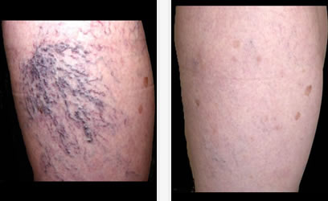
What causes Spider Veins?
Spider veins can be caused by the backup of blood, hormone changes, exposure to sun and injuries.

Treatment for Spider Veins:
- Sclerotherapy is a minimally invasive procedure done by your healthcare provider to treat uncomplicated spider veins and uncomplicated reticular veins. The treatment involves the injection of a solution into the affected veins. Asclera® is a sclerosing agent that is injected into the vein. It works by damaging the inner wall of the vein, and eventually causing the vein to collapse on itself. Over time, the damaged vein is replaced with tissue. Individual results may vary, and many patients will require multiple injection sessions for complete treatment success.
After
Before

- Laser treatment. While sclerotherapy is more common, the smaller, fine, reddish spider veins respond best to laser treatment because they’re harder to inject, Laser surgery works by sending strong bursts of light into the vein that make the vein slowly fade and disappear. No incisions or needles are used. The treatment is often less effective than sclerotherapy and can have side effects, including redness, bruising, itching and swelling in the treated area. Complications of laser surgery include blistering of the skin. When the blisters heal, they can leave permanent scars.

After treatment, blood vessels gradually fade over several months, but they may not disappear completely. Also, new spider veins can develop in the same area that could warrant additional treatments.

How to prevent Spider Veins

- Relieve the pressure - Keep weight down and avoid standing or sitting for long periods. It is recommended that if you have to sit for long periods avoid crossing your legs while sitting and take a short walk every 30 minutes or so. Avoid wearing high-heeled shoes. High heels put extra pressure on your legs and can restrict the flow of blood causing limited circulation.

- Exercise – Keep the blood flowing – walking or running will not only increase leg circulation but it will also strengthen your leg muscles.

- Eat less salt and more fiber. Salt causes your body to retain water and swell which can put pressure on veins. Fiber prevents constipation which is another form of pressure that can cause spider veins to appear.

- Support – If you must be on your feet for long periods of time, a lightweight compression stocking will help with managing and preventing spider vein symptoms. The compression stocking can also help prevent swelling.

- Elevate your legs – Go ahead – prop up those feet! Your legs must be elevated higher than your heart for the best effect.

- Sunscreen – Do you have light skin? Sun exposure can lead to spider veins on your cheeks and nose – so slather on the sunscreen to minimize the damage.

- Varicose Veins – If you have varicose veins have them treated. Varicose veins have non-working valves that allow blood to collect inside them. Having varicose veins treated can reduce the pressure in the legs and prevent the development of additional spider veins.

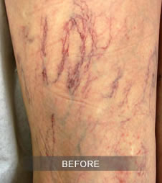
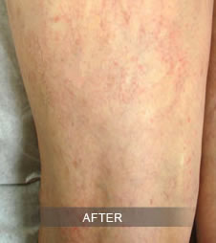
Spider veins are mainly a cosmetic issue and can be left alone if they don’t bother you. But if you’re unhappy about the way they look or if they’re painful, you can do something about them. Give Great Lakes Surgical Associates a call for a consultation. Call now 716-434-6141.

